Industrial Training Report
On

WEB DEVELOPMENT USING MERN STACK
(Site Map Generator for Users)
(Subject Code: NBCA-507P)

Submitted in partial fulfilment of the requirement for the award of the degree
of
BACHELOR OF COMPUTER APPLICATION

Submitted by
SUHANI YADAV
[2312044050155]
Under the guidance of
Ms. Pushpanjali


DEPARTMENT OF COMPUTER APPLICATION,
SHRI RAMSWAROOP MEMORIAL COLLEGE OF MANAGEMENT, LUCKNOW

Affiliated to

LUCKNOW UNIVERSITY, LUCKNOW



August – 2025



ABSTRACT

The “Sitemap Generator for Users” is a web-based application designed to automatically generate sitemaps for websites entered by users. A sitemap is a vital tool for improving a website’s visibility on search engines, as it provides a structured list of accessible pages that can be indexed.

In the digital age, maintaining an up-to-date sitemap is essential for enhancing a website’s SEO, structure, and user navigation. However, many users lack the technical expertise or tools to generate comprehensive sitemaps easily. This project addresses that problem by developing a Site Map Generator for Users using the MERN (MongoDB, Express.js, React.js, Node.js) stack.

The system allows users to input a website URL and automatically crawls all internal links to generate a structured sitemap. The backend, built using Node.js and Express.js, handles the crawling logic and API development. MongoDB is used for storing user credentials and generated sitemap data. The frontend, developed in React.js, provides a user-friendly interface for user registration, login, sitemap input, and result viewing.

ACKNOWLEDGEMENT

I would like to express my heartfelt gratitude to everyone who contributed to the successful completion of this project, “Site Map Generator for user”.
First and foremost, I am deeply thankful to my mentor and guide Ms. Pushpanjali, for their invaluable support, guidance, and encouragement throughout this project. Their insights and feedback were crucial in shaping the development of the application.
I would also like to extend my sincere thanks to our HOD Dr. Santosh Kumar Dwivedi and entire faculty and staff of SRMCM, whose teaching and resources provided the foundational knowledge and skills necessary for this work.
A special thanks goes to my colleagues, who provided constant motivation and constructive feedback, helping me stay on track and improve the project at every stage.
Lastly, I am grateful to my family for their unwavering support and patience, allowing me the time and space to focus on this project.
This project would not have been possible without the collective efforts and encouragement of all these individuals, and for that, I am truly appreciative.


SUHANI YADAV

DECLARATION

I, SUHANI YADAV, hereby declare that the project work entitled “Site Map Generator for users” submitted to SRMCM Lucknow is a record of an original work done by me under the guidance of MS. PUSHPANJALI during JULY 2025, and this work is submitted in the partial fulfilment of the requirements for the award of the degree of Bachelor of Computer Application.
I further declare that this project is my own work and has not been previously submitted to any other institution for any other degree, diploma, or certification. All sources of information used in this report have been duly acknowledged.
I certify that all the information provided in this report is true and correct to the best of my knowledge.

SUHANI YADAV
1-Aug-2025
Lucknow

TABLE OF CONTENTS

TOPIC PAGE:
- COVER PAGE………………………………………………………. i
- CERTIFICATE……………………………………………………… ii
- ABSTRACT…………………………………………………………. iii
- ACKNOWLEDGEMENT………………………………………….. iv
- DECLARATION……………………………………………………. v
- CHAPTER 1………………………………………………………… 1
- Introduction
- CHAPTER 2………………………………………………………… 2
- Problem Definition
- Objective
- Methodology
- CHAPTER 3………………………………………………………… 3
- Project Objective
- Aim of Project
- Scope O Project
- Ideas and Approaches of Proposed Work
- CHAPTER 4………………………………………………………… 6
- Proposed Methodology
- Block Diagram
- Description of Each block
- CHAPTER 5………………………………………………………… 8
- SDLC
- Prototype Model
- Related Technologies
- Planning and Scheduling

- CHAPTER 6………………………………………………………… 14
- Hardware, Software Requirements and Specifications
- Hardware Requirements
- Software Requirements
- GUI Specifications
- Module Description
- CHAPTER 7………………………………………………………… 16
- Data Flow Diagrams
- Use Case Diagram
- ER Diagram
- CHAPTER 8………………………………………………………… 22
- Testing Methodologies
- CHAPTER 9………………………………………………………… 23
- Project Screenshots
- Future Scope of Project…………………………………………….. 26
- Conclusion…………………………………………………………… 27
- References……………………………………………………………. 28

CHAPTER- 01

1. INTRODUCTION:

General Background
In today’s digital world, websites play a crucial role in delivering content, services, and experiences to users. As websites grow larger and more complex, it becomes increasingly important to maintain proper structure and navigation. A sitemap is a vital tool that helps both users and search engines understand the overall architecture of a website. It lists all accessible URLs in a structured format, facilitating better indexing and visibility on search engines like Google.

Traditionally, creating a sitemap manually is time-consuming and prone to errors, especially for dynamic websites with multiple pages. To address this issue, automation tools are needed that can efficiently crawl a website and generate a sitemap in a usable format.

This project, Site Map Generator for Users, aims to simplify the process of sitemap creation by providing a web-based tool that allows users to input a website URL and receive a structured sitemap as output. Built using the MERN (MongoDB, Express.js, React.js, Node.js) stack, the application supports automated crawling, link extraction, and visual sitemap representation. It also offers features such as reverse countdown, downloading options, and optional database integration to store and manage results.

This project combines practical web development skills with real-world application, making it a valuable tool for developers, SEO professionals, and website administrators.

CHAPTER - 02

2.PROBLEM DEFINITION:

2.1 General Objective:
The primary objective of this project is to create an efficient and easy-to-use web application for generating sitemaps. It enables users to enter a website URL and receive a complete list of all internal links. This sitemap helps in understanding the structure of a website and is useful for SEO optimization. The project aims to automate the crawling process and present results in both downloadable and visual formats. Users can download the sitemap in .txt or .html formats. It also allows saving crawled data to a MongoDB database. Additional features include a countdown timer during processing and optional email support. The system is built using the MERN stack to ensure responsiveness and scalability.

  - Methodology:
Front-End Development:
- The frontend is built using HTML, CSS, JavaScript, and Tailwind CSS for a responsive UI. Users input a URL, and the interface displays a reverse countdown timer and results dynamically. Options to download the sitemap in .txt or .html format are also provided.
Back-End Development
- The backend is developed with Node.js and Express.js to handle API requests. It uses Axios and Cheerio to crawl websites and extract internal links. The backend processes and sends the sitemap data to the frontend.

Database Integration
- MongoDB stores submitted URLs and their sitemap data for record keeping. Mongoose is used for easy interaction with the database

CHAPTER- 03

- PROJECT OBJECTIVE:

  - AIM OF PROJECT:

- Sitemap Generation: To develop a tool that can crawl and generate a sitemap from a user-provided website URL.
- Result Visualization and Download: To allow users to view the sitemap structure and download it in .txt or .html format.
- Database Integration: To use MongoDB for storing user-submitted URLs and the generated sitemap data.
- User Interface: To provide a responsive, clean, and user-friendly frontend for easy interaction.
- Authentication System: To implement a login feature for secure access and user session management.
- Enhanced User Experience: To improve usability with features like a reverse countdown timer and an optional visual sitemap view.

  - PROJECT OBJECTIVE:

  - Enhanced User Experience: To improve usability through features like a reverse countdown timer and optional visual sitemap tree.
  - Database Storage: To store user input and crawled sitemap data in MongoDB for record-keeping and future reference.
  - User-Friendly Interface: To design a responsive and intuitive frontend where users can enter URLs and view results easily.
  - User Authentication: To implement a login system that ensures secure access and protects user-specific data.
  - Automated Sitemap Creation: To build a system that automatically crawls a website and generates a complete sitemap of internal links.

3.3 SCOPE OF PROJECT:

- Responsive Web Interface: A clean and user-friendly interface helps users input URLs and view sitemap results easily.
- Sitemap Generation: The project allows users to generate sitemaps by crawling internal links of any valid website.
- Database Integration: MongoDB is used to store user inputs and the corresponding sitemap data securely.
- Downloadable Sitemaps: Users can download the generated sitemap in .txt or .html format.
- User Authentication: Only registered users can access the sitemap generator through a secure login system.

  - IDEAS AND APPROACH OF PROPOSED WORK:

While there is no doubt that this application is inspired by the concept of real-time sitemap generation tools, it has been further enhanced and modified based on user-level needs and practical improvements.

IDEAS:
- User-Friendly Interface: The idea of creating an easy-to-use, visually clean, and responsive interface came from analyzing popular online tools. It was implemented using HTML, CSS, JavaScript, and Tailwind CSS to ensure users can interact smoothly with the system.
- Automated Sitemap Crawling: The tool is designed to automatically crawl a website starting from a given URL and extract all internal links. This core idea simplifies the tedious manual process of sitemap creation and improves SEO visibility.
- Downloadable Sitemap Files: A key feature allows users to download the generated sitemap in .txt or .html format. This idea ensures users can use the sitemap immediately in their own systems or upload it to search engines.
- Optional Visual Sitemap Tree: A feature to show the sitemap in a tree view structure was considered to help users better understand the website’s link hierarchy, making the experience more visual and informative.

APPROACHES:
- Modular Development Approach: The project was divided into key modules—frontend, backend, database, and authentication—each developed and tested separately to ensure better maintainability and scalability.
- Full-Stack Web Development: The MERN stack (MongoDB, Express.js, React or plain JS, Node.js) was used to build a complete web application, integrating both server-side and client-side functionalities efficiently.
- User-Centered Design: The interface and features were designed keeping user needs and ease-of-use in mind. Feedback from similar tools was analyzed to enhance usability and responsiveness.
- Recursive Web Crawling Logic: A recursive crawling algorithm was implemented to fetch all internal links of the entered URL while avoiding duplicates and infinite loops using sets and filters.
- Secure Data Handling: JWT-based authentication and bcrypt password hashing were used to ensure that only logged-in users can access the sitemap generator securely.

CHAPTER
-

04

4
:
. PROPOSED METHODOLOGY

:
BLOCK DIAGRAM
4.1

User
I
nter
face

User Sign up and Login

Backend Processing

Crawling logic

User Input and Interaction

Database Management

MongoDB
(
)

Sitemap Generation

Result display and Download

4.2 Description of Each Block:

User Interface Development
This block handles the design and interaction elements of the project. Built using React.js and Tailwind CSS, it allows users to enter the target website URL, see the countdown timer, and view the generated sitemap. It ensures a responsive and clean interface for both desktop and mobile users.
- Backend Processing
This module acts as a bridge between frontend and backend. It is created using Node.js and Express.js. It receives the URL from the frontend, initiates the crawling process, and responds with the results. It also manages errors, status updates, and process timings.

- Crawling Logic
The heart of the project, this block implements the crawling mechanism. Using packages like axios, cheerio, or puppeteer, it visits the given website URL and recursively collects internal links. It ensures that only valid and non-duplicate URLs from the same domain are included in the sitemap.

- Sitemap Generation
This block organizes the list of collected URLs into a structured format (e.g., .txt, .html, or .xml). It arranges the URLs hierarchically, mimicking the site’s structure. The output is formatted for clarity and compatibility with SEO tools or manual inspection.

- Result Display and Download
This module displays the generated sitemap on the frontend after the timer ends. It also provides options to download the sitemap in .txt or .html formats. The user is shown a clean and readable output with the ability to view or save the data.

- Data Storage (MongoDB)
This module is responsible for storing crawled data and user sessions into the MongoDB database. It helps in maintaining a log of all generated sitemaps and allows for future reference, analysis, or re-downloads.

CHAPTER-05

5.SOFTWARE DEVELOPMENT LIFE CYCLE(SDLC):

SDLC is a process followed for software building within a software organization. SDLC consists of a precise plan that describes how to develop, maintain, replace, and enhance specific software. The life cycle defines a method for improving the quality of software and the all-around development process.
Software development life cycle (SDLC) is a structured process that is used to design, develop, and test good-quality software. SDLC, or software development life cycle, is a methodology that defines the entire procedure of software development step-by-step.
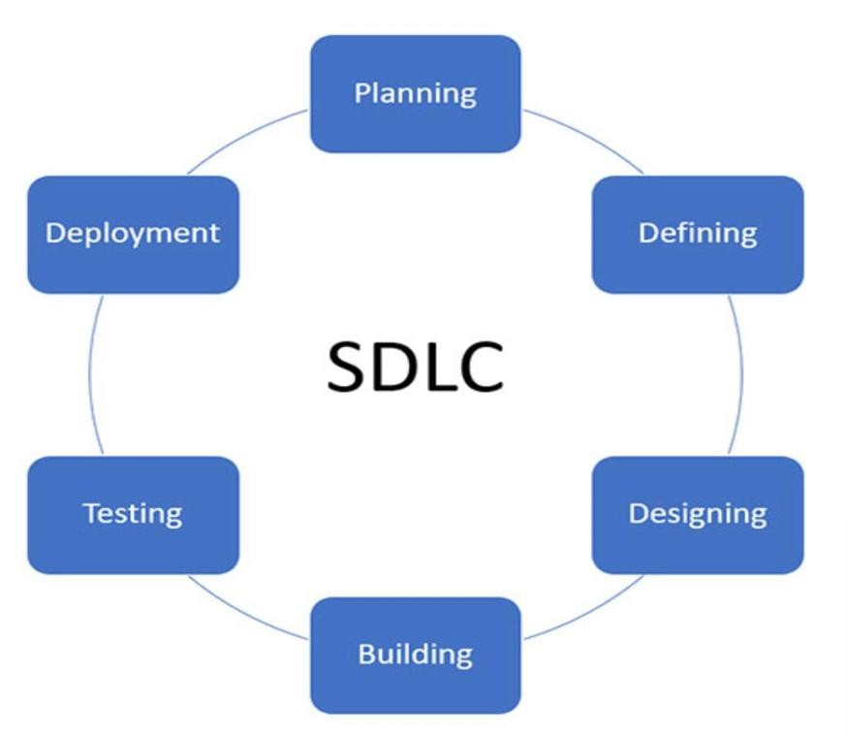

5.1 Stages of SDLC:

1. Requirement Gathering and Analysis
- Purpose: To understand what the users need from the software.
- Activities: Meetings with stakeholders, clients, or end-users to collect functional and non-functional requirements.
- Outcome: A Software Requirement Specification (SRS) document is prepared.

2. System Design
- Purpose: To plan the architecture and technical structure of the system.
- Activities: Designing the system layout, database schema, UI/UX structure, and selecting technologies.
- Outcome: Design Documents, Wireframes, and System Architecture Diagrams.

3. Implementation (Coding)
- Purpose: To convert the system design into actual source code.
- Activities: Developers write code in the chosen programming languages and implement features based on the design.
- Outcome: A working software product (initial version).

4. Testing
- Purpose: To ensure the software is free of bugs and works as expected.
- Activities: Performing different levels of testing like unit testing, integration testing, system testing, and user acceptance testing (UAT).
- Outcome: A bug-free and quality-assured software ready for deployment.

5. Deployment
- Purpose: To make the software live and available for users.
- Activities: Installing the software on production servers or distributing it to users via cloud or installer.
- Outcome: The software becomes available to end users.

6. Maintenance and Support
- Purpose: To ensure the software continues to work correctly after deployment.
- Activities: Fixing bugs, updating software, improving performance, and adding new features based on user feedback.
- Outcome: A stable and evolving product over time.

6. PROTOTYPE MODEL:

The Prototyping model is also a popular software development life cycle model. The prototyping model can be considered to be an extension of the Iterative Waterfall model. This model suggests building a working Prototype of the system, before the development of the actual software. A prototype is a toy and crude implementation of a system.
The prototyping model is especially useful when the exact technical solutions are unclear to the development team. A prototype can help them to critically examine the technical issues associated with the product development. The lack of familiarity with a required development technology is a technical risk.

6.1 Phases of Prototype Model:
The software is developed through two major activities – one is prototype construction and another is iterative waterfall based software development.

Prototype Development – Prototype development starts with an initial requirements gathering phase. A quick design is carried out and a prototype is built. The developed prototype is submitted to the customer for evaluation. Based on the customer feedback, the requirements are refined and the prototype is suitably modified. This cycle of obtaining customer feedback and modifying the prototype continues till the customer approves the prototype.
Iterative Development – Once the customer approves the prototype, the actual software is developed using the iterative waterfall approach. In spite of the availability of a working prototype, the SRS document is usually needed to be developed since the SRS Document is invaluable for carrying out tractability analysis, verification and test case design during later phases.

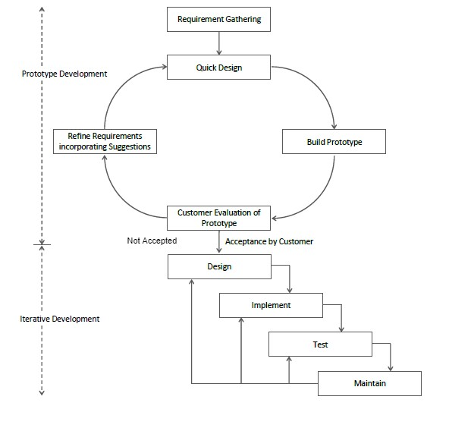

    - The code for the prototype is usually thrown away. However, the experience gathered from developing the prototype helps a great deal in developing the actual software. By constructing the prototype and submitting it for user evaluation, many customer requirements get properly defined and technical issues get resolved by experimenting with the prototype.

Advantages of Prototyping Model – This model is most appropriate for the projects that suffer from technical and requirements risks. A constructed prototype helps to overcome these risks.

7.Related Technology:

- Frontend: The frontend of the Sitemap Generator is built using HTML, CSS, Tailwind CSS, and JavaScript. HTML structures the web page, while Tailwind CSS provides a responsive and modern UI. JavaScript adds interactivity by handling user input, form validation, countdown timer, and displaying the sitemap results dynamically.
- Backend: The backend is developed using Node.js and Express.js to handle server-side logic and API communication. Axios is used to fetch webpage content, and Cheerio parses that content to extract internal links for sitemap creation. MongoDB, along with Mongoose, is used to store user data and generated sitemaps.

  - Description of Algorithms:
- User Authentication Algorithm
This algorithm verifies user login credentials by matching the email and password against data stored in MongoDB. It uses JWT for generating access tokens, ensuring that only authenticated users can access protected routes.
- Link Validation & Filtering Algorithm
Before crawling, this algorithm checks the format of the input URL and filters out invalid or external links during crawling. It ensures only valid internal URLs are included in the sitemap, improving performance and accuracy.

7.2 Salient Features of the Proposed Design:
1. Secure User Login - Implements JWT-based authentication and bcrypt for password encryption to ensure only authorized access.
2. Easy URL Input Interface - Users can easily input any website URL through a clean and intuitive form layout.
3. Efficient Web Crawling - Crawls all internal links from the given URL using axios and cheerio, avoiding duplicates and loops.
4. Downloadable Sitemap Output - Allows users to download the sitemap results in .txt or .html format for practical use.
5. MongoDB Data Storage - Stores user details and generated sitemap data securely using MongoDB and Mongoose for easy retrieval.

8. Planning and Scheduling

In the Sitemap Generator project, effective planning and scheduling are key to ensuring the smooth development and timely delivery of the application. Planning begins by clearly defining the project's scope, objectives, and core deliverables—primarily focused on building a user-friendly tool that generates, displays, and stores website sitemaps based on user input. The initial planning phase includes conducting a feasibility analysis, identifying the technical stack (MERN), preparing a project charter, and allocating resources such as team roles and development tools.
Scheduling involves creating a structured timeline that outlines major development phases, including frontend design, backend API development, web crawling algorithm implementation, authentication setup, database integration, and testing. Tools like Gantt charts or project management boards (e.g., Trello, Jira) can be used to define milestones and deadlines, such as the completion of the URL input form, crawler module, reverse countdown timer, and download feature. Effective planning and scheduling are crucial for maintaining project momentum and achieving a successful implementation of the customer complaint classification system.
1 | Project Initiation | 2 Days | 01/07/25 | 02/07/25
2 | Draft Project Plan | 2 Days | 03/07/25 | 04/07/25
3 | Analysis Phase | 1 Days | 05/07/25 | 05/07/25
4 | Plan User Interviews | 1 Days | 06/07/25 | 06/07/25
5 | Scheduling user interviews | 2 Days | 07/07/25 | 08/07/25
6 | Conducting user interviews | 1 Days | 09/07/25 | 09/07/25
7 | System Design | 2 Days | 10/07/25 | 11/07/25
8 | Modules Design | 2Days | 12/07/25 | 13/07/25
9 | Data Structure Design | 1 Days | 14/07/25 | 14/07/25
10 | User Interface Design | 2 Days | 15/07/25 | 16/07/25
11 | Coding Phase | 3 Days | 17/07/25 | 19/07/25
12 | Testing Phase | 2Days | 20/07/25 | 21/07/25
13 | Integration Testing | 1Days | 22/07/25 | 22/07/25
14 | System Level testing | 2 Days | 23/07/25 | 24/07/25
15 | Implementation | 2 Days | 25/07/25 | 26/07/25
16 | Post-Implementation review | 2 Days | 27/07/25 | 28/07/25

CHAPTER – 06

9. Software/Hardware Requirements and Specifications
  - Software Requirements
  - Operating System:
    - Windows 10/11 o macOS 10.15 or later o Linux distributions (Ubuntu 18.04 or later)
• Programming Language: JavaScript
- Libraries/Frameworks: React.js, Axios, Node.js, Express.js
  - Database: MongoDB, Mongoose

9.2 Hardware Requirements
  - Processor: Minimum: Dual-core processor (Intel Core i3 or equivalent)
  - RAM: Minimum: 4 GB
  - Storage: Minimum: 250 MB of free space for software installation
  - Display: Minimum: 1024x768 resolution
  - Other Peripherals: Keyboard and mouse

9.3 GUI Specifications:
- The interface is designed to be user-friendly, with easy navigation across the application’s features.
- The application supports mouse and keyboard inputs and provides feedback to the user during interactions (e.g., loading screens, progress indicators).

10.MODULE DESCRIPTIONS
- User Input Module
This module allows users to enter the URL of the website they want to generate a sitemap for. It includes input validation to ensure the URL is in the correct format before processing. It acts as the starting point of the sitemap generation workflow.
- Crawler Module
The crawler module is responsible for visiting the main URL and recursively exploring all internal links. It fetches pages and collects their URLs, ensuring no duplicate or external links are included. It forms the core logic for generating the sitemap.
- Sitemap Generation Module
After crawling the site, this module organizes all collected URLs into a structured format (like XML or plain list). It supports both HTML and TXT export options. This module ensures the output is standardized and ready for download or display.
- Result Display Module
Once the sitemap is ready, this module presents it in a readable format on the frontend. It may include a scrollable list or a collapsible tree view to show the structure of the website. It also provides options to download the sitemap.
- Download Module
This module enables users to download the generated sitemap in .txt or .html format. It ensures file generation and handling are smooth and secure. File naming and saving options are also managed here.

CHAPTER-07

11. DATA FLOW DIAGRAM(DFD):

Data Flow Diagram (DFD) represents the flow of data within information systems. Data Flow Diagrams (DFD) provide a graphical representation of the data flow of a system that can be understood by both technical and non-technical users. The models enable software engineers, customers, and users to work together effectively during the analysis and specification of requirements.

11.1 DFD ELEMENTS:
• Source/Sinks
A Square defines a source or destination of system Data

- Data Flows
An arrow identifies the data flow in motion

- Processes
A circle represents a process that transfers informing data flows into outgoing data flows.

• Data Stores
An open rectangle is a data store-data at rest or a temporary

11.2 Levels of Data Flow Diagram (DFD)
Data Flow Diagram (DFD) uses hierarchy to maintain transparency thus multilevel Data Flow Diagram (DFD’s) can be created.

- Zero Level DFD:
It’s designed to be an abstraction view, showing the system as a single process with its relationship to external entities. It represents the entire system as a single bubble with input and output data indicated by incoming/outgoing arrows.
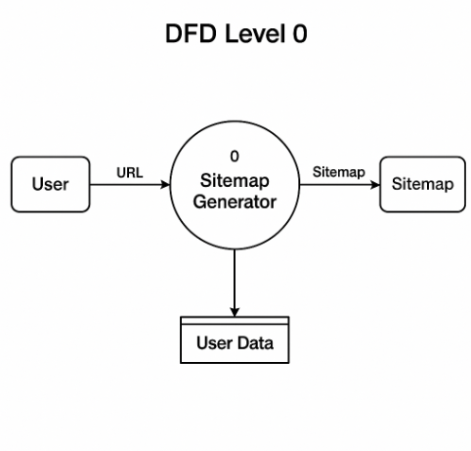
- First Level DFD:
1-Level provides a more detailed view of the system by breaking down the major processes identified in the level 0 Data Flow Diagram (DFD) into sub-processes. Each sub-process is depicted as a separate process on the level 1 Data Flow Diagram (DFD). The data flows and data stores associated with each sub-process are also shown. In 1-level Data Flow Diagram (DFD), the context diagram is decomposed into multiple bubbles/processes. In this level, we highlight the main functions of the system and breakdown the high-level process of 0-level Data Flow Diagram (DFD) into subprocesses.
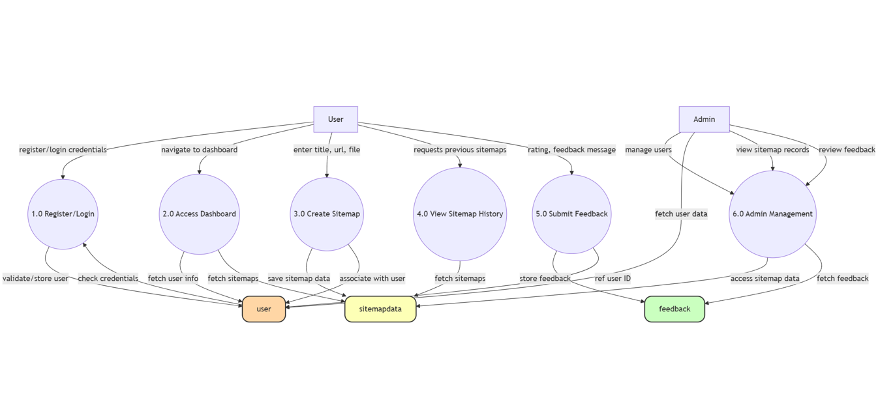

12 USE CASE DIAGRAM:
A Use Case Diagram is a vital tool in system design that provides a visual representation of how users interact with a system. It serves as a blueprint for understanding the functional requirements of a system from a user’s perspective, aiding in the communication between stakeholders and guiding the development process.

NOTATIONS OF USE-CASE DIAGRAM
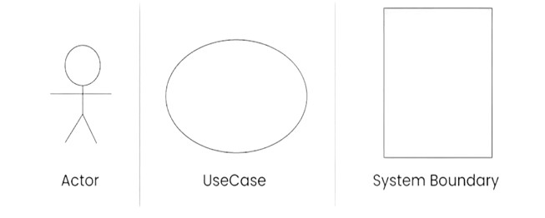

SYSTEM

SIGNUP/
LOGIN

ENTER URLS

MANAGE DATABASES
DOWNLOAD SITEMAP

USER ADMIN
VIEW SITEMAPS

LOGOUT

13. E-R DIAGRAM:

Peter Chen developed the ER diagram in 1976. The ER model was created to provide a simple and understandable model for representing the structure and logic of databases. It has since evolved into variations such as the Enhanced ER Model and the Object Relationship Model.
Symbols are:

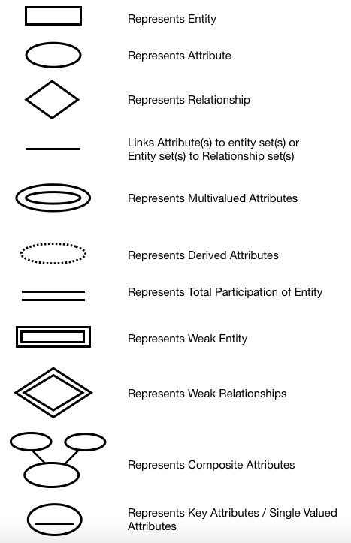

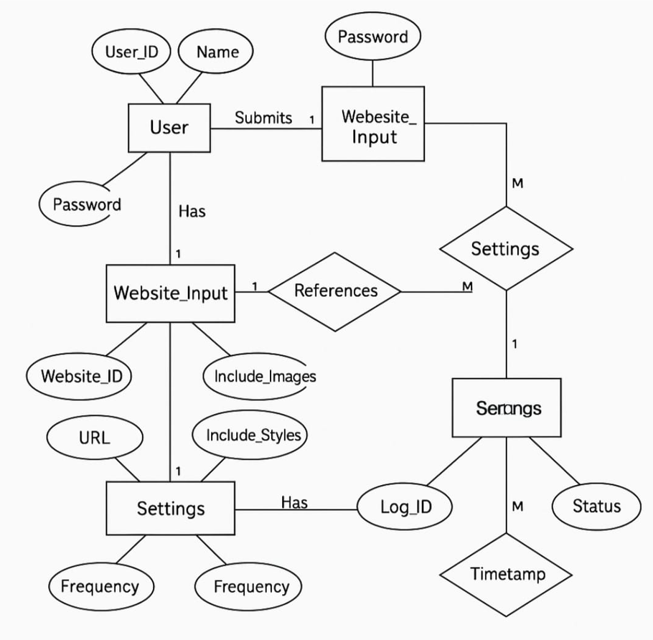
SettingsId

CHAPTER -08

14.TESTING METHODOLOGIES:

Testing methodology refers to the systematic approach used to ensure that software or systems function correctly and meet specified requirements. It encompasses various strategies and techniques to identify and fix issues before deployment.
Here’s an overview of key testing methodologies:

- Unit Testing: Unit testing was performed on individual components such as the input form, sitemap generation logic, and file download feature. Each module was tested with valid and invalid inputs to ensure correct behaviour in isolation.
- Integration Testing: Integration testing verified the interaction between the frontend, backend, and database. It ensured smooth data flow from URL submission to sitemap generation and storage, confirming the system works as a complete unit.
- Functional Testing: Functional testing focused on the main features like input validation, sitemap crawling, reverse countdown timer, and download options. Each function was checked against the expected requirements to ensure they work correctly.
- UI Testing: The user interface was tested for responsiveness and usability across different screen sizes and devices. All UI elements like buttons, forms, and visual feedback were checked for proper alignment and functionality.
- Performance Testing: The application was tested for performance by generating sitemaps for both small and large websites. The system’s response time and stability were measured to ensure it handles load efficiently.
- Security Testing: Security testing included validating input data, checking for vulnerabilities like XSS and injection attacks, and ensuring safe handling of user inputs. It also ensured that sensitive data is protected during processing.

CHAPTER – 09

15.Project Screenshots

Home page:

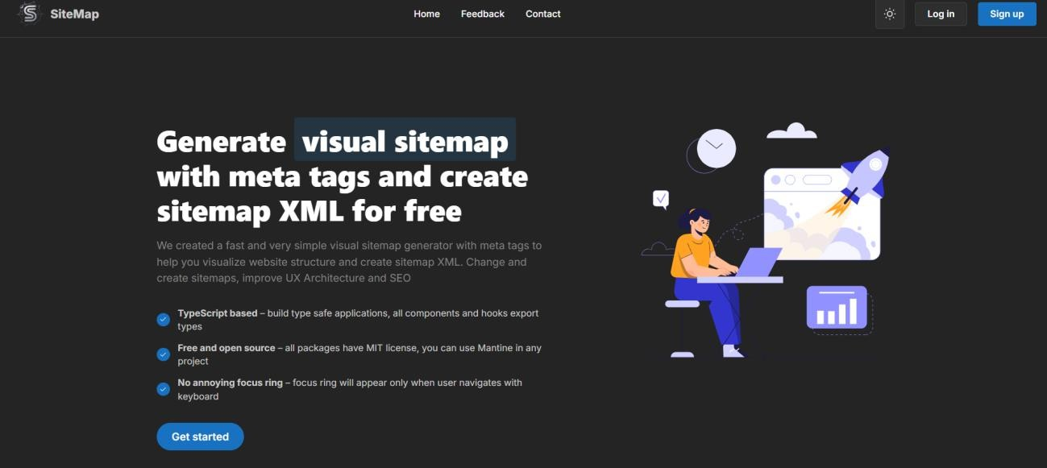

Feedback page:

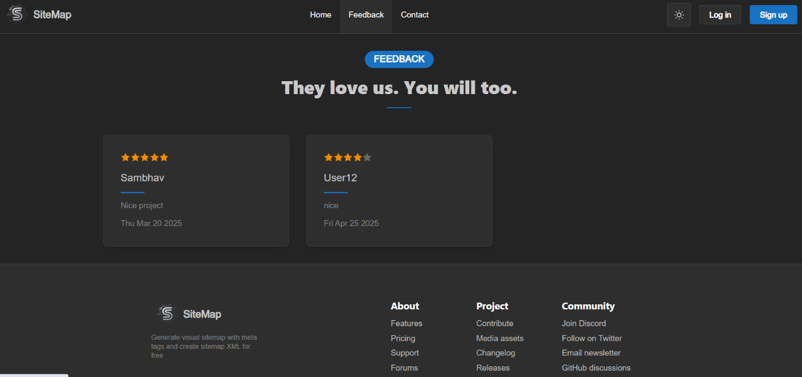

Contact page:

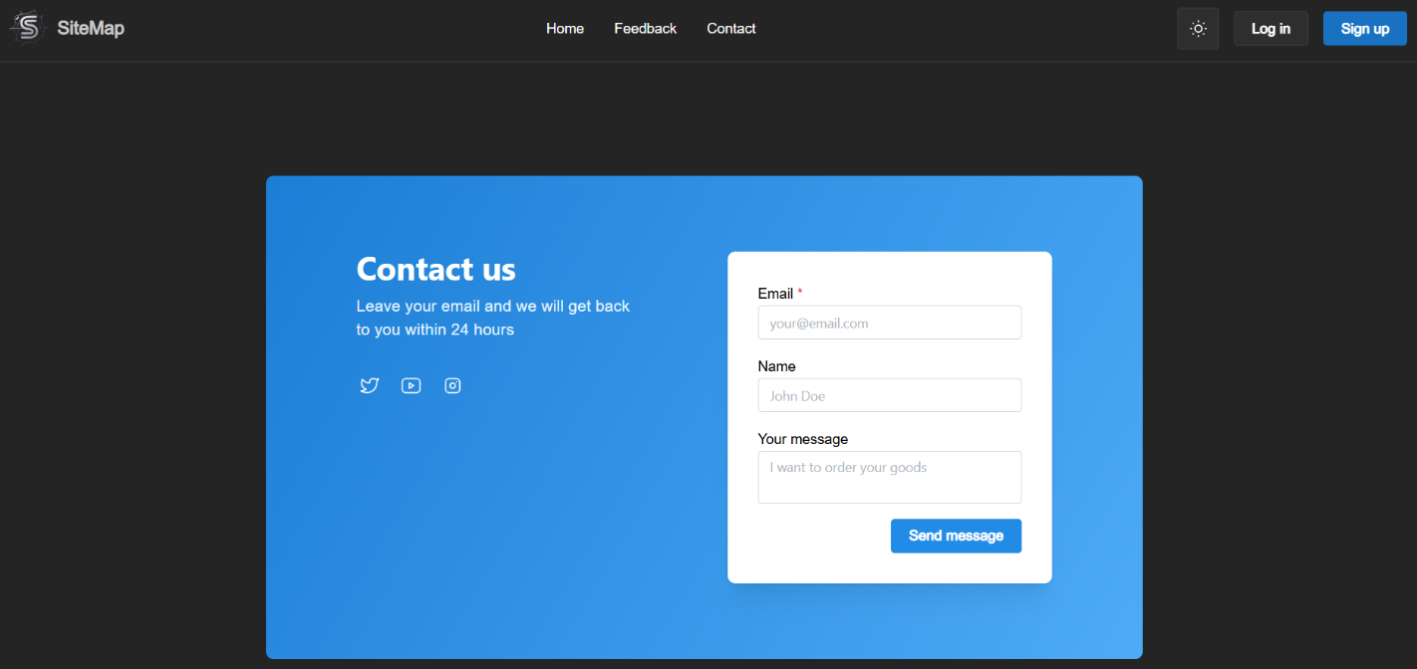

Login page:

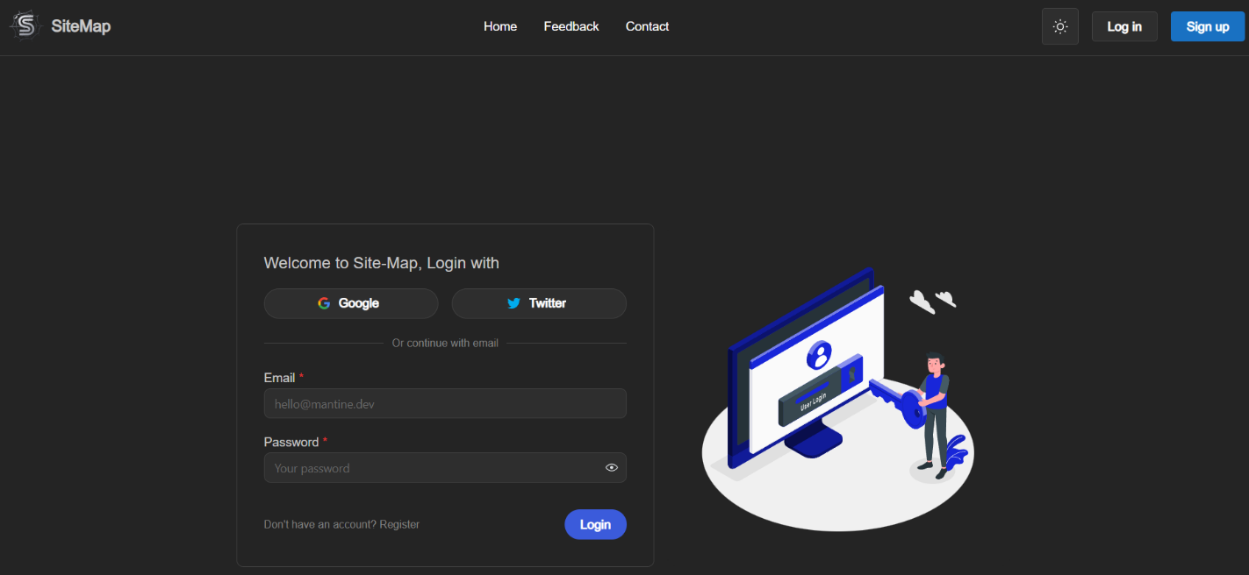

Sitemap Generator Page:

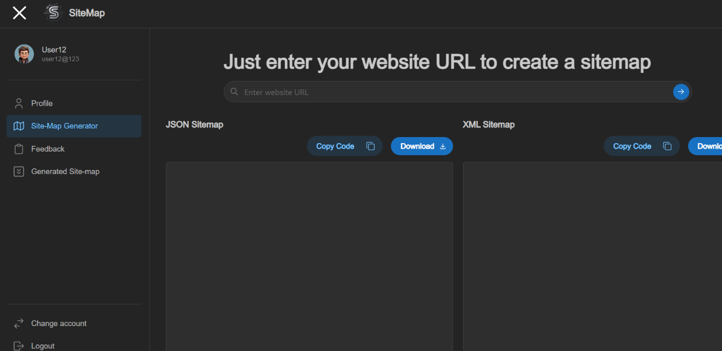

FUTURE SCOPE OF THE PROJECT

The Site Map Generator has strong potential for future development and expansion. As website technologies, SEO algorithms, and user expectations evolve, the tool can be enhanced with advanced features and broader integration capabilities. Below are key areas of future scope:
1. Dynamic Sitemap Updating
- Implement automatic tracking and updating of sitemaps whenever the website content changes.
- Integration with content management systems (CMS) like WordPress, Joomla, etc., for real-time updates.
2. Multi-Language and Internationalization Support
- Generate localized sitemaps for multi-language websites.
- Add support for global websites targeting multiple regions.
3. Advanced SEO Insights
- Include SEO health checks such as identifying broken links, orphan pages, and duplicate content.
- Provide suggestions for improving page structure and metadata.
4. Visual Sitemap Representation
- Generate an interactive, visual sitemap (tree or graph view) for easier content management and user understanding.
5. Cloud Storage & Versioning
- Allow users to store sitemap versions in the cloud and track changes over time.
6. Mobile App Version
- Develop a mobile app version for on-the-go sitemap monitoring, generation, and updates.

CONCLUSION
The Site Map Generator serves as a vital tool for enhancing website visibility, improving SEO performance, and simplifying technical tasks related to sitemap creation. By automating the process of scanning, analyzing, and structuring website URLs into search-engine-friendly formats (XML, HTML, TXT), it eliminates the need for manual sitemap generation—which can be time-consuming, error-prone, and difficult for non-technical users.
Through its user-friendly interface, flexible customization options, and reliable performance, the tool addresses the major challenges faced by website owners, developers, and SEO professionals. It ensures complete website indexing, faster search engine discovery, and better site organization.
In conclusion, the Site Map Generator not only bridges the gap between technical requirements and user accessibility but also contributes significantly to the overall efficiency, visibility, and success of any web presence.

REFERENCES

BOOKS:
- S. Shah, Full Stack Web Development with MERN, BPB Publications, 2022.
- E. Freeman and E. Robson, Head First HTML and CSS, 2nd ed., O'Reilly Media, 2012.
- M. Cantelon, M. Harter, B. Rajlich, and T. Holowaychuk, Node.js in Action, 2nd ed., Manning Publications, 2017.

WEBSITES:
- W3Schools, “HTML Sitemap Generator Tutorial,” [Online]. Available: https://www.w3schools.com/howto/howto_website_create_sitemap.asp
- XML Sitemaps, “How to create a sitemap,” [Online]. Available: https://www.xml-sitemaps.com/
- Node.js Foundation, “Node.js Documentation,” [Online]. Available: https://nodejs.org/en/docs/
- MongoDB, “MongoDB Documentation,” [Online]. Available: https://www.mongodb.com/docs/

